Database Programming with PL/SQL

3-1: Review of SQL DML

Practice Activities

Vocabulary

|  |  |
| --- | --- |
| DELETE | Statement used to remove existing rows in a table. |
| INSERT | Statement used to add new rows to a table. |
| MERGE | Statement used to INSERT and/or UPDATE a target table, based on matching values in a source table. |
| UPDATE | Statement used to modify existing rows in a table. |
| DDL | When you create, change, or delete an object in a database. |
| DML | When you change data in an object (for example, by inserting or deleting rows) |

1. Evaluate the following SQL statement.

DELETE FROM students;

This SQL statement will:

false A. Not execute due to wrong syntax

false B. Delete the first row from STUDENTS

true C. Delete all rows from STUDENTS

false D. None of the above

2. Evaluate the following SQL statement.

INSERT INTO STUDENTS (id, last_name, first_name)

VALUES (29,'Perez','Jessica');

This SQL statement:

true A. Does an explicit insert

false B. Does an implicit insert

Use the following table for questions 3 through 8.

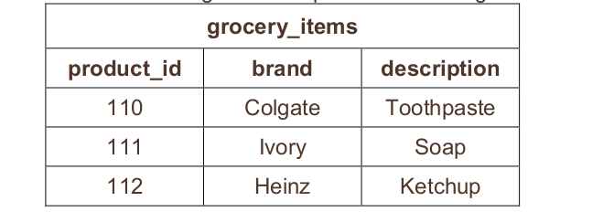

3. Write a SQL statement to create the above table.

create table grocery_items (

product_id NUMBER CONSTRAINT grocery_items_pk_on PRIMARY KEY ENABLE,

brand VARCHAR2(50),

description VARCHAR2(50))

4. Write and execute three SQL statements to explicitly add the above data to the table.

insert into grocery_items (product_id, brand, description)

values (110, 'Colgate', 'Toothpaste')

insert into grocery_items (product_id, brand, description)

values (111, 'Ivory', 'Soap')

insert into grocery_items (product_id, brand, description)

values (112, 'Heinz', 'Ketchup')

5. Write and execute a SQL statement that will explicitly add your favorite beverage to the table.

insert into grocery_items (product_id, brand, description)

values (113, 'Ginger Ale', 'Bere')

6. Write and execute a SQL statement that modifies the description for Heinz ketchup to “tomato

catsup”.

update grocery_items

set description = 'tomato catsup'

where brand = 'Heinz'

7. Write and execute a SQL statement that will implicitly add your favorite candy to the table.

insert into grocery_items (product_id, brand, description)

values (114, 'Ed, Edd n Eddy', 'Jaw Breakers')

8. Write and execute a SQL statement that changes the soap brand from “Ivory” to “Dove.”

update grocery_items

set brand = 'Dove'

where brand = 'Ivory'

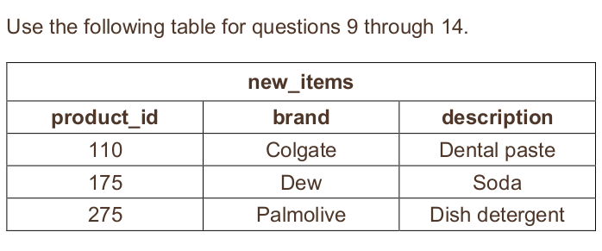9. Write and execute SQL statements to create the new_items table and populate it with the data in

the table.

create table new_items (

product_id NUMBER CONSTRAINT new_items_pk_on PRIMARY KEY ENABLE,

brand VARCHAR2(50),

description VARCHAR2(50))

insert into new_items (product_id, brand, description)

values (110, 'Colgate', 'Dental Paste')

insert into new_items (product_id, brand, description)

values (175, 'Dew', 'Soda')

insert into new_items (product_id, brand, description)

values (275, 'Palmolive', 'Dish Detergent')

10. Write a SQL statement that will update the grocery_items table with the brand and description

from the new_items table when the product ID values match. If they don’t match, add a new row to

the grocery_items table. DO NOT EXECUTE YOUR STATEMENT YET.

MERGE into grocery_items G

USING new_items N

ON (G.product_id = N.product_id)

WHEN NOT MATCHED THEN

INSERT (G.product_id, G.brand, G.description)

VALUES (N.product_id, N.brand, N.description)

11. How many rows will be updated by the SQL statement in question 10?

7 rows

12. How many rows will be inserted by the SQL statement in question 10?

2 rows

13. Which of the following is true about the SQL statement in question 10?

A. new_items is the source table and grocery_items is the target table.true

B. grocery_items is the source table and new_items is the target table.false

14. Execute the SQL statement you wrote in question 10, and then SELECT all data from the

grocery_items table to verify your answers to questions 11 and 12.

select * from grocery_items

order by product_id